**Jaypee University of Engineering and technology**

**Name - Rahul Bairagi Submitted to - Dr.Amit Kumar Shrivastava**

Enrollment No - 201B204 Batch B7

Date : 19-02-2022

**Operating Systems Lab Manual**

**System Specifications**

System - Dell inspiron 3516 : 64Bit

Operating System - Windows 11

Ram - 8GB

Processor-Intel core i5 10th Gen

SSD - 256GB

HDD - 1TB

Graphic Card - Nvidia 2GB

**LAB 1: How to install Virtual Box on our system**

**1**.Visit <https://www.virtualbox.org/wiki/Downloads>

and download windows hosts.

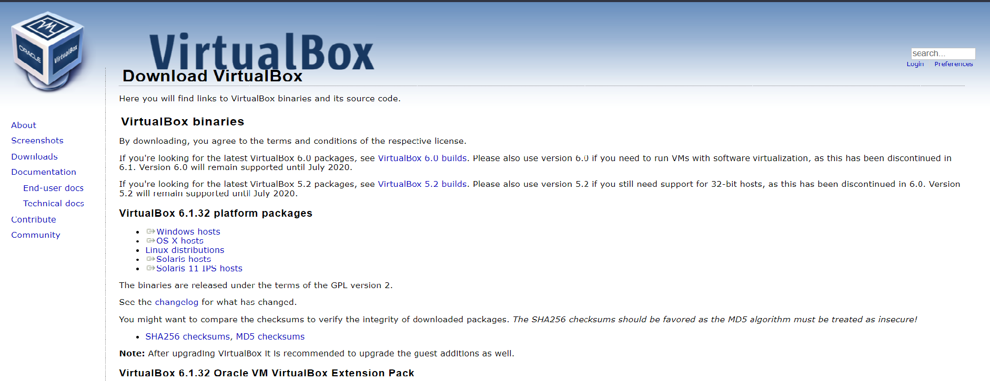

**2**. When previous download is completed visit <https://www.centos.org/download/>

and download CentOS Linux x86_64.

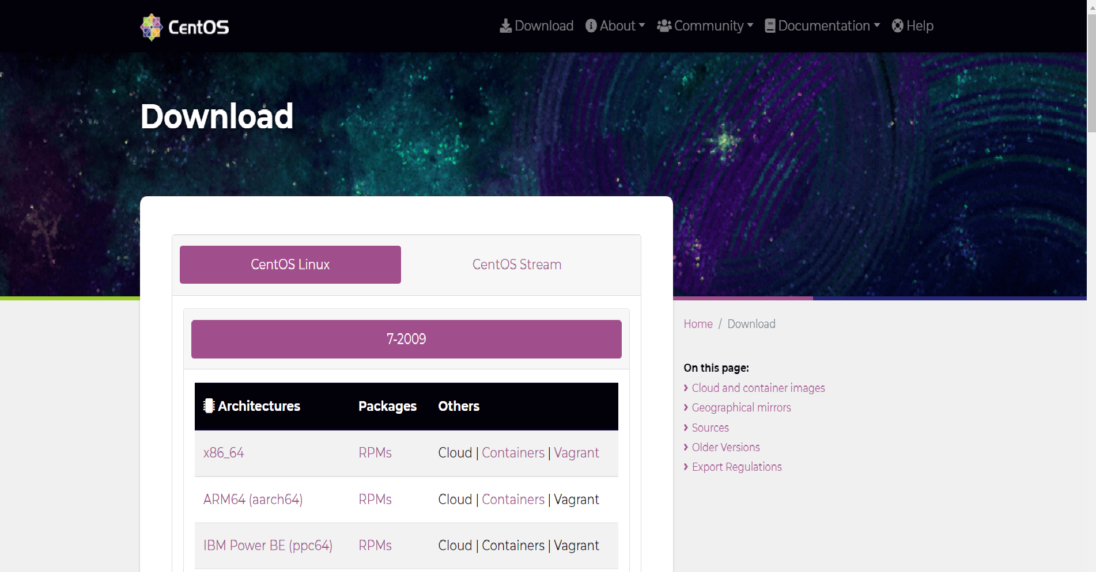

**3.** Install Virtualbox,exe file on your system. Open and then click New.

**4.** Type name for your virtual machine , Type will be Linux and version will be redhat 64 Bit.

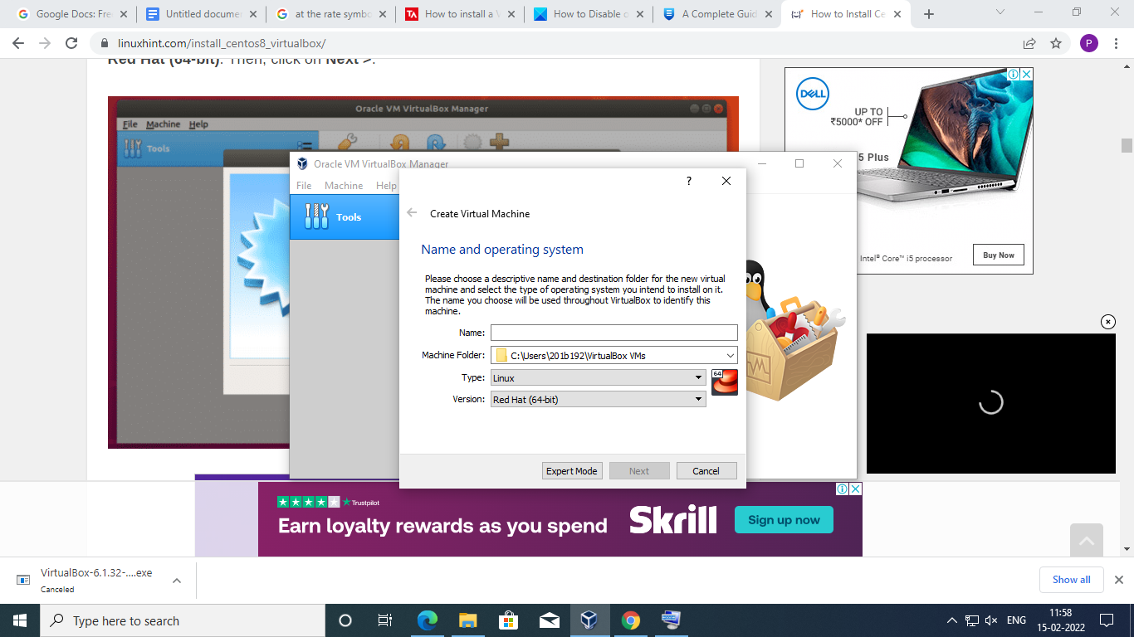

Select Next.

**5.**Now select 2GB of Ram size.

**6.**Select Virtual Hard Diskthenclick onHard disk file type will be Virtual disk file image

**7**. Select Memory to be dynamically allocated not statically because in case of dynamically allocated memory space usage will be less.

**8.** Size of File type will be 40GB . Click Create.

**9.** Click on Network , then select Adapter1 select enable network attached to NAT & select name NAT Network.

**10.** Click on create then your virtual machine will be created.

**11.** Below Tools there will be options for your virtual machine .

Select your virtual machine and open settings

**12.** Now go to storage tab click on CD icon and click on Virtual optical disk file radio button choose Centos installation file & click open.

**13.** Start your virtual machine and Select Install CentOS Linux & click Enter

**14.**Select desired language as English

1**5.** Select Installation destination(40 GB Hard disk) and start it, Select Storage configuration to be automatic.

**16.** Start installation

**17.** After Installation is completed.Create new login user , type your username and password then click on user creation.

**18.**Type your name , username , password, confirm password and then select new user. Now your installation is completed and Linux Red hat 64 bit is ready to use.